P. Yashwanth
192412422
3. Design a Functional Architecture for Real-Time Edge Data Processing in Industrial Automation
Code:
clc;
clear;
close all;
%% Parameters
N = 200; % Number of samples
threshold = 80; % Temperature threshold
time = 1:N;
%% Sensor Data Generation
temperature = 60 + 10*sin(0.1*time) + randn(1,N)*3;
%% Edge Processing
filteredData = movmean(temperature,5);
status = strings(1,N);
for i = 1:N
% Data Acquisition
sensorValue = filteredData(i);
% Local Decision
if sensorValue > threshold
status(i) = "ALERT";
else
status(i) = "NORMAL";
end
end
%% Display Results
disp('Time Temp Status')
for i = 1:N
fprintf('%3d %6.2f %s\n',time(i),filteredData(i),status(i));
end
%% Cloud Transmission (Simulation)
cloudData = table(time',filteredData',status',...
'VariableNames',{'Time','Temperature','Status'});
disp(' ');
disp('Data sent to Cloud');
disp(cloudData(1:10,:));
%% Plot
figure;
subplot(2,1,1)
plot(time,temperature,'b');
hold on
plot(time,filteredData,'r','LineWidth',2);
yline(threshold,'k--','Threshold');
xlabel('Time');
ylabel('Temperature');
title('Sensor Data and Edge Filter');
legend('Raw Data','Filtered Data','Threshold');
grid on
subplot(2,1,2)
plot(time,filteredData,'LineWidth',2);
hold on
alertIndex = filteredData > threshold;
plot(time(alertIndex),filteredData(alertIndex),'ro','MarkerFaceColor','r');
xlabel('Time');
ylabel('Temperature');
title('Real-Time Edge Anomaly Detection');
grid on
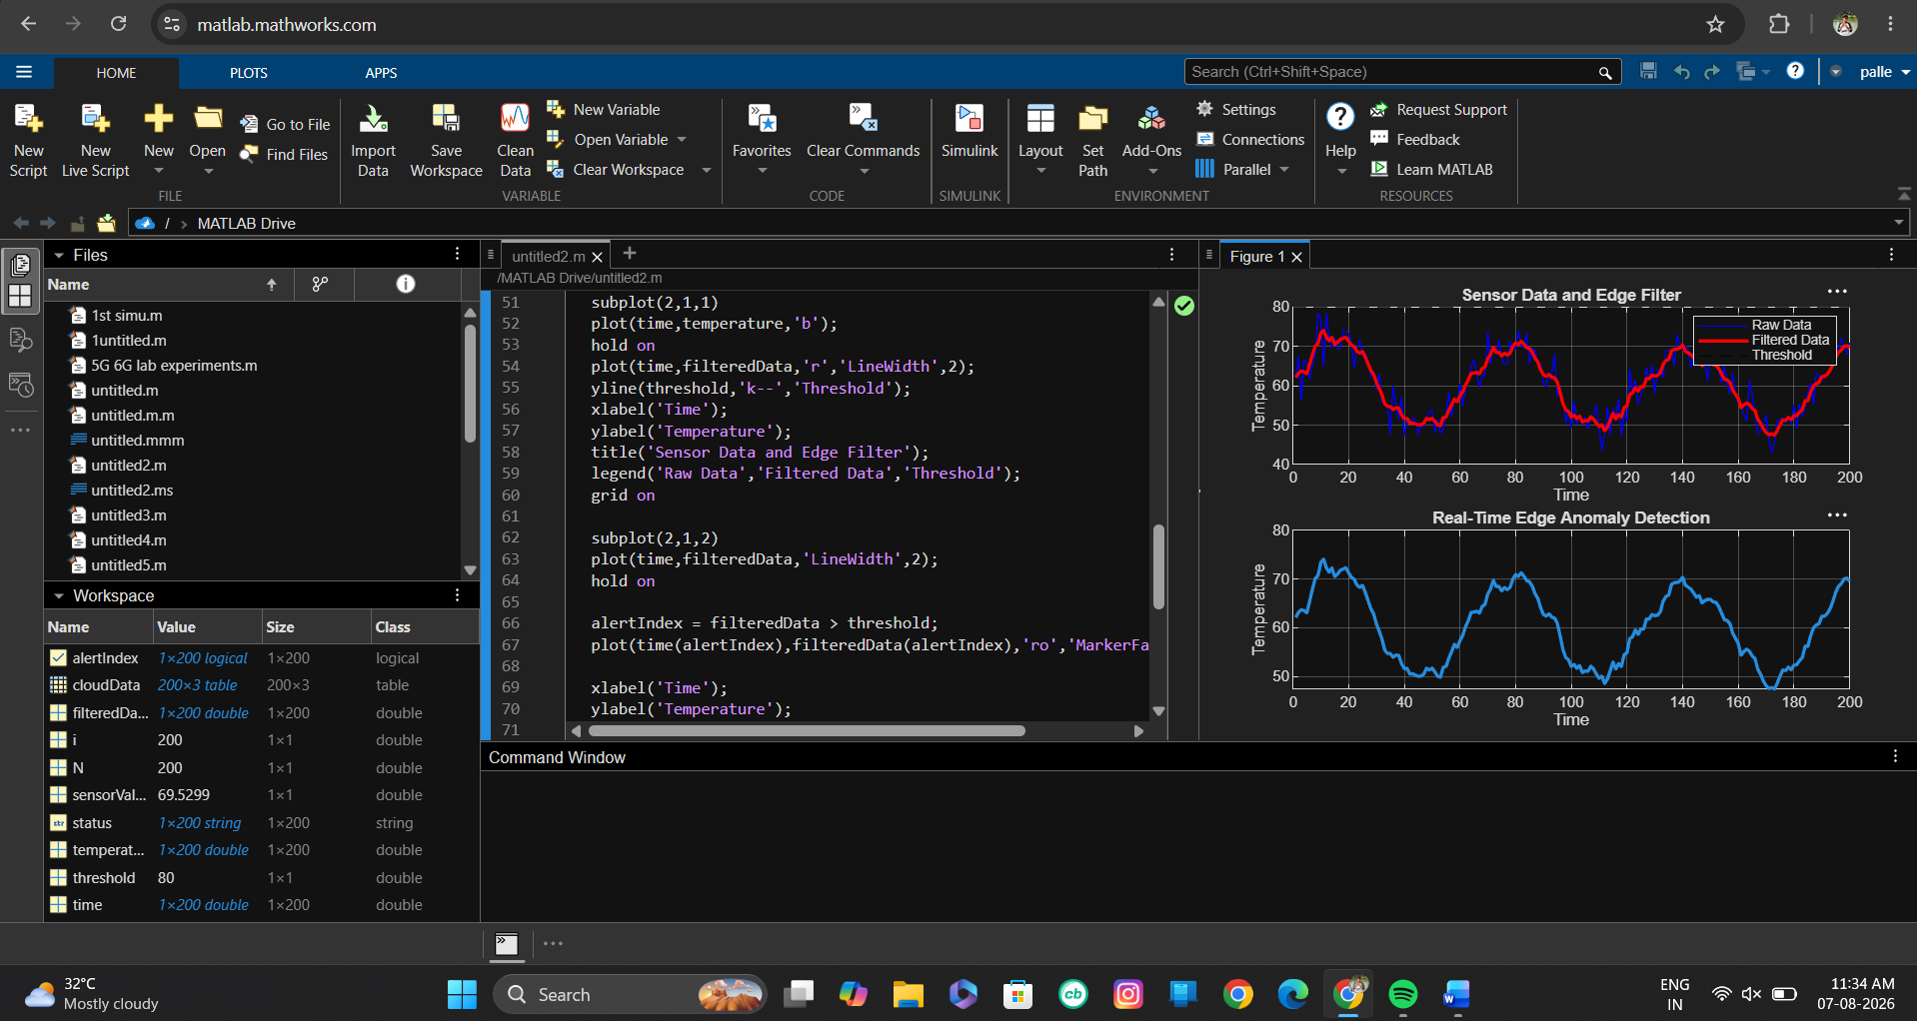

9. Design a Cloud Radio Access Network Model for Dense Urban Deployment
Code:
clc;
clear;
close all;
%% Simulation Parameters
numRRH = 8; % Number of Remote Radio Heads
numUsers = 100; % Number of Users
area = 1000; % Deployment area (meters)
Pt = 46; % Transmit Power (dBm)
BW = 20e6; % Bandwidth (20 MHz)
noise = -100; % Noise Power (dBm)
%% Generate RRH Locations
RRH_x = area*rand(numRRH,1);
RRH_y = area*rand(numRRH,1);
%% Generate User Locations
User_x = area*rand(numUsers,1);
User_y = area*rand(numUsers,1);
%% Plot Network
figure;
scatter(RRH_x,RRH_y,150,'r','filled');
hold on;
scatter(User_x,User_y,40,'b','filled');
xlabel('X Position (m)');
ylabel('Y Position (m)');
title('Cloud Radio Access Network (C-RAN)');
legend('RRH','Users');
grid on;
%% User Association
connectedRRH = zeros(numUsers,1);
distance = zeros(numUsers,1);
for i = 1:numUsers
d = sqrt((RRH_x-User_x(i)).^2 + (RRH_y-User_y(i)).^2);
[distance(i),connectedRRH(i)] = min(d);
end
%% Path Loss Model
pathLoss = 128.1 + 37.6*log10(distance/1000);
%% Received Signal Power
Pr = Pt - pathLoss;
%% Signal-to-Noise Ratio
SNR = Pr - noise;
%% Shannon Capacity
capacity = BW*log2(1 + 10.^(SNR/10));
%% Results
fprintf('Average Distance = %.2f meters\n',mean(distance));
fprintf('Average SNR = %.2f dB\n',mean(SNR));
fprintf('Average Throughput = %.2f Mbps\n',mean(capacity)/1e6);
%% User Connections
figure;
for i=1:numUsers
plot([User_x(i) RRH_x(connectedRRH(i))],...
[User_y(i) RRH_y(connectedRRH(i))],'k');
hold on;
end
scatter(RRH_x,RRH_y,150,'r','filled');
scatter(User_x,User_y,35,'b','filled');
xlabel('X Position (m)');
ylabel('Y Position (m)');
title('User Association with RRHs');
grid on;
%% Throughput Distribution
figure;
histogram(capacity/1e6,15);
xlabel('Throughput (Mbps)');
ylabel('Number of Users');
title('User Throughput Distribution');
grid on;
